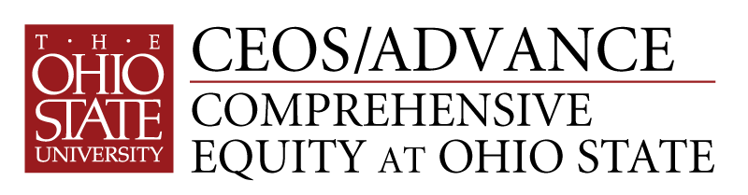

*leading to excellence*

**Project Reach**

***Extend the Reach of your Research***

A Special Workshop Series for Tenured Women at Ohio State

The potential of commercialization to provide impact

Applications/Nominations Due January 14, 2011

Every faculty member wants her research to make a difference, yet most view the end product of their work as the refereed publication or conference presentation. This workshop series will introduce faculty to a different route to provide impact, by partnering with commercial entities.

As part of its overall goal to enhance the success of women faculty in the STEM disciplines (science, technology, engineering, and mathematics), CEOS has designed a series of four workshops to help faculty explore the potential of commercialization as an alternative avenue for their research results. The first cohort completed the series in 2010. The four workshops for 2011 are:

**Workshop 1: The potential of research ideas to become marketable**. This workshop will feature successful women entrepreneurs currently working at OSU who have taken various routes to commercialize their research results. Then participants will explore their own research programs and identify possible areas that could be useful in the marketplace. (Friday, Feb. 4, 2-5 p.m.)

**Workshop 2: The commercialization process at Ohio State**. This workshop will describe the process and infrastructure in place to help faculty commercialize their intellectual property. During the workshop participants will explore the multiple routes available for commercialization and identify those most promising for their own applications.(Friday, March 4, 2-5 p.m.)

**Workshop 3: Skills needed to engage successfully in commercialization**. Faculty are highly creative, and many of the skills honed in research careers are important for entrepreneurial success as well. In addition, faculty need to acquire new skills that will allow them to behave in a new environment. This workshop will include self-analysis as well as case studies to allow participants to gauge their readiness for entrepreneurial activity. (tentative date: Friday, April 8, 2-5 p.m.)

**Workshop 4: Introduction to the world of business**. Most faculty will not own their own businesses, yet successful commercialization requires that they understand how business works and especially how it differs from academic culture. This workshop will feature women faculty who receive industrial funding, who have attracted venture capital, and who have started their own businesses. (tentative date: Friday, May 6, 2-5 p.m.)

The Details

**When**?

We plan to offer the workshops once per month on Friday afternoons from 2-5 p.m. on February 4, March 4, April 8 (tentative date) and May 6 (tentative date). We have designed these workshops to follow a developmental process, and therefore participants should plan to attend all four.

**Who**?

The workshops target tenured women working in a STEM discipline, from any unit within the University. Others may be accommodated on a space-available basis. We plan a cohort of 12 - 15 individuals.

We ask Deans and Chairs to nominate individual women faculty to participate; we will follow up with nominees. Individuals may also apply on the understanding that they have their dean’s and chair’s support.

**Where?**

All workshops will be held on campus to promote full participation.

**How?**

Interested faculty should fill out the application form, secure appropriate signatures, and submit via email to [ceos@osu.edu](mailto:ceos@osu.edu) by January 14, 2011. We intend to notify applicants the following week of their status.

We ask each participant to secure the support of her chair and dean to participate in this series. The Dean must commit to providing $400 tuition for the participant.

**Questions?**

Joan Herbers Deb Ballam

Principal Investigator Program Director

292-5472 247-1879

[herbers.4@osu.edu](mailto:herbers.4@osu.edu) ballam.1@osu.edu

Project CEOS

104 Aronoff Laboratory

318 W. 12th